EN:Walkie-talkie set

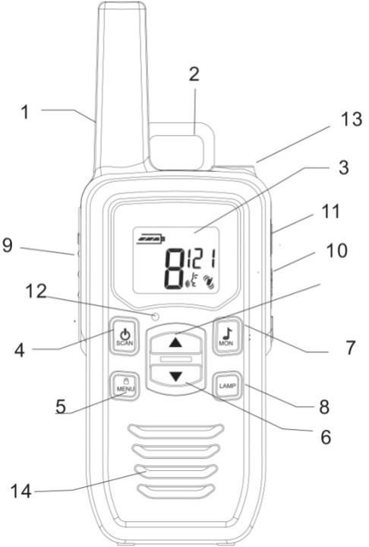

Function description

1. Antenna

2. Belt clip: The belt clip is attached for easy use.

3. LCD display: Displays current channel selection and other radio status symbols.
4. Power/Scanbutton:

Press and hold the Power/Scanbutton to turn your unit on/off.

Press the Power/Scan button to search for channels.
5. MENU/LOCKbutton:

Press the MENU/LOCKbutton to Channel and function select or.

Press and hold the MENU/LOC button to Lock/unlock the channel.
6. UPDOWNbutton:

Press the UPDOWNbutton to adjust the volume level and to change channels.
7. CALL/MONbutton:

Press CALL/MONbutton to CALL.

Press and hold CALL/MONbutton to Monitor.
8. LAMPbutton:

Press and hold LAMPbutton to until sending light.

Press and hold LAMPbutton to until the light is OFF.

9. PTT button : Press the PTT button to transmit.

10.SPK/MIC Socket: It is 3.5mm earphone jack. The earphone is excluded in package. It needs to purchase separately.

11.Charge Jack :The device can support the Micro USB charging (5V, 1A). It is compatible with most of 5V smartphone charger on the market.

12.Microphone.

13.LAMP.

14.Speaker.

Display icon description:
 | Transmitting icon, displayed when transmitting a signal.
 | Display of current volume value.
 | Display of the Channel Scan mode.
 | Keyboard is locked.
 | Display of the current battery level.
 | Channel number.
 | subchannel (1-121)
 | vox function activated (sound sensor)

BATTERY INSTALLATION:

Remove the belt clip by pulling the tab and sliding it up.

Pull the battery door lock tab down to release the battery cover. Insert 3 "AA" batteries.

Replace the battery cover. Snap the lock tab and belt clip back into place.

To use the radio, you must install 3 "AA" size batteries.

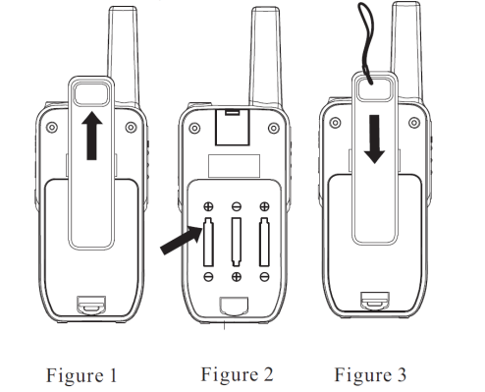

Turning the unit ON
Press and hold the powerbutton. The unit will beep and the LCD display will display the current channel.

Turning the unit OFF
Press and hold the powerbutton,The unit will beep and the LCD display will turn in blank.

Adjusting the speaker volume
Press the UPbutton to increase the speaker volume.
Press the DOWNbutton to decrease the speaker volume.
The speaker volume level is indicated by the number.

Receiving Communications
When the walkie-talkie is switched on and not being used for speech or papering,it is always in the receiving mode .
Press the PTT button, it will turn to sending mode automatically.

Calling another radio
Turn the volume up to an audible level.
Set both units to the same channel.
Press CALL button to CALL
The other unit will make a 2 second call tone. They can respond to your call by either:
Press the PTT button and speaking into the radio, or
Press CALL button double times to CALL, which activates a 2 second call tone on your radio.
- Momentary monitor:
This feature aims to receive weak signals at the maximum range. When it the MON function is on, it will turn off the squelch feature, either momentarily or continuously. It helps in receiving signals to its maximum range, but may pick up static signals, too.
Press and hold Call button until a beep sound is heard
Release the button to restore the automatic squelch.
CHANNEL LOCK:
This feature is to lock the channel so that the channel cannot be changed accidentally.
To lock the channel, press and hold MENU buttons until a beep sound is heard.The lock symbol will appear on the display.
To unlock the channel, press and hold MENU buttons until a beep sound is heard. The lock symbol will disappear.
Setting the Channels
The walkie-talkies has multi-channels. To change channels:
Press the MENU button until the current channel number flash on the LCD display.
Press the UPbutton to move to a higher channel.
Press the DOWN button to move to a lower channel.
Press the PTT button to choose the desired Channel and return
to normal mode, or press the MENUbutton to the next menu.

Setting the Subchannels
To avoid disturbing signals nearby ,the walkie-talkie has 121subchannels.
Press the MENUbutton until the channel number flash on the display.
press the MENUbutton until the subchannels in the upper right corner of the display begins to flash.
press the UPor DOWNbuttons to switch between the 121 subchannel.
Press and PTT button to confirm the subchannel.
To deactivate a subchannel,press the Menubutton and press the UPor DOWNbuttons until OF is shown in the display.
press the PTT button to confirm,or press the MENU button to next menu .
- Setting The VOX function
The vox function reacts to voice and sound.
Do not use the function if you are in surroundings with strong winds or a lot of noise .
Press the MENUbutton until the channel number flash on the display.
Press the MENUtwo times.The VOX function will be shown in the display.
Press the UPor DOWNbutton to adjust sensitivity to sound (3=most sensitive to sound).
To deactivate the VOX function,Press the the UP or DOWNbutton until the “OF” is shown in the display.
Press the PTT button to confirm,The walkie talkie now returns to normal function,or press the MENU button to next menu.
- Setting the call ring melody
The walkie talkie has 10 different ring tones
Press the MENU button until the channel number flash on the display.
Press the MENU button three times until the numbers begin to flash in the upper right corner of the display.
Press the UPor DOWNbutton to select your call ring melody.
To deactivate call,and press the UP or DOWN buttons until the “OF” is shown in the display.
Press the PTT button to confirm.Setting the button tone
Press the MENUbutton until the channel number flash on the display
Press the MENU button four times until the numbers.
Press the UPor DOWNbutton to select ON or OF .
Press and hold PTT button to confirm

Setting the PTT tone
Press the MENU button until the channel number flash on the display
Press the MENU button five times until the numbers.
Press the UPor DOWNbutton to select ON or OFF.
Press and hold PTT button to confirm.
Setting the button tone
Press the button until the channel number flash on the display
Press the button five times until the numbers
Press the or button to select ON or OF.
Press and hold PTT button to confirm

Built-in flashlight
The walkie talkie has a built-in flashlight that can be used in sending light signals or for your lighting needs.
press and hold LAMP button until sending light.
press and hold LAMP button until off light.

Low battery indicator
When the batteries need to be changed, the battery level icon will flash. To ensure uninterrupted communication, Recharge or replace the batteries as soon as possible.

Charging the radio
To charge the radio, it requires using 3 AA NI-MH rechargeable batteries.Insert the adapter's micro USB plug to DC IN 5V USB jack
Charge the batteries for 12 hours and remove the radio after charging.

