Parent’s Guide
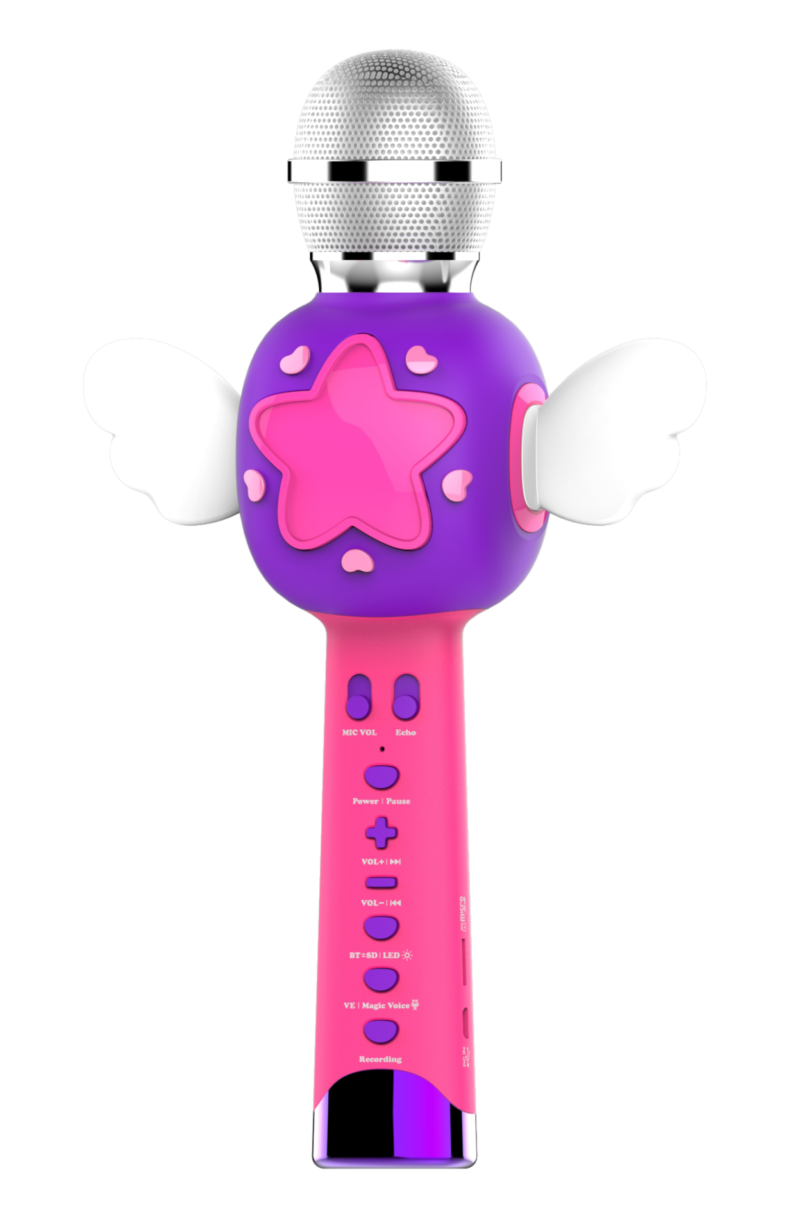

Introduction
Thank you for purchasing the KOMVOX Angel Wing Karaoke Microphone!!
Grab the microphone and sing along to eight great songs or any of your favorite songs available on your device or play the songs saved on your Micro SD card.

Product Features
Product Layout and Buttons
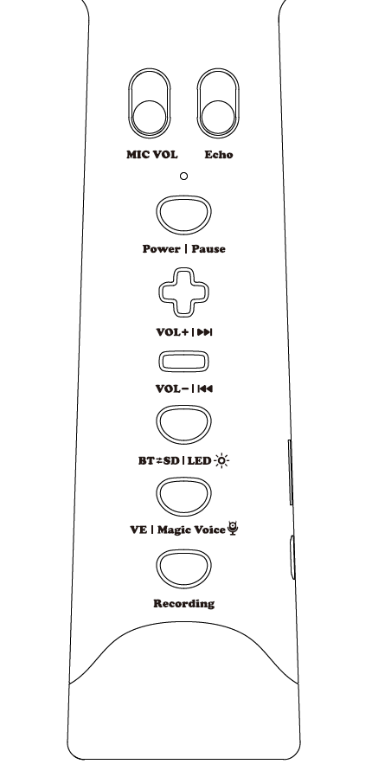
Speaker Volume Down
Last Song
Power Control
Playing Pause
Microphone Volume Control
Recording
Vocal Elimination
Magic Voice
BT/SD Playing Mode Switch
LED Control
Speaker Volume up
Next Song
Echo Effect Control

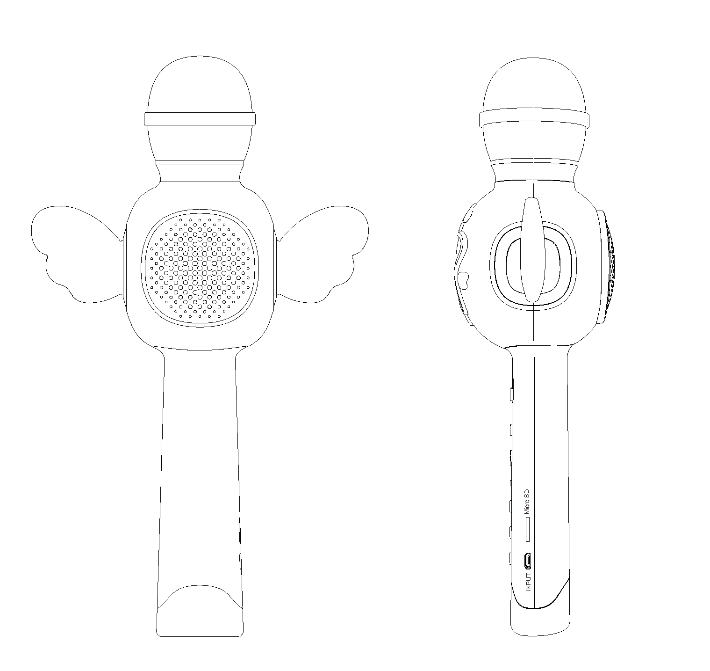
Microphone
Angel Wing
Charging Slot
Micro SD Card Slot
Speaker
Buttons On the Microphone
 | Microphone Volume Control | Switch to control the volume of microphone.
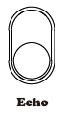 | Echo Effect Control | Switch to control the Echo effect.
 | Power ON/OFF  Pause the Song Playing | - Long press 3 seconds to switch On/Off the device.  - Short press 1 second to pause the song playing.
 | Speaker Volume Increase  Next Song | - Short press the button to increase the speaker volume.  - Long press the button to switch next song.
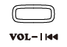 | Speaker Volume Decrease  Last Song | - Short press the button to decrease the speaker volume.  - Long press the button to switch last song.
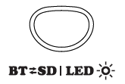 | Switch BT and SD mode  LED Light Control | - Short Press the button to switch the BT and SD playing mode.  - Long press the button to turn ON/OFF LED light.
 | Vocal Eliminator  Magic Voice | - Short Press the button to turn on the Vocal Elimination.  - Long press the button to turn on the Magic Voice.
 | Recording | Set the BT mode and press the button to record your singing. Press the button again to stop the recording and replay the recording voice.  When you replay the recording voice, the system switch to SD mode automatically. You need to set back the BT mode if you want.
 | Micro SD card slot | There is a 128MB Micro SD with built-in songs inside. And the recording function only works when the SD card is inside.  It can support Max. 32GB micro SD card.
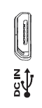 | Micro USB Charging Slot | It is for any 5V, 1A~2A Micro USB charging.

Included In this Package
- One Karaoke Microphone
- One Micro USB charging cable
- One 128MB Micro SD card inside the device
- One User Manual

WARNING:
All packing materials such as tape, plastic sheets, packaging locks, removable tags, cable ties are not part of this toy, and should be discarded for your child’s safety.
NOTE:
Please keep this parent’s guide as it contains important information.

TO BEGIN USING
KOMVOX Angel Wing Karaoke Microphone
TURN ON THE UNIT
Long Press the ON/OFF Button to turn on the unit ON and enter the BT play mode.
LOW POWER
When the battery is exhausted, it will notice “LOW POWER” when you turn on the unit. And the unit will shut off automatically in 1 minute.

AUTOMATIC SHUT OFF
To preserve battery life, Angel Wing Karaoke Microphone will automatically power off if there is no operation for a period of time.

CHARGING
The unit is charging by micro USB cable. You can use any smartphone adaptor to charge the unit.
When the unit is under charging, the RED indicator is flashing. When the charging is full, the indicator will turn off.

VOLUME CONTROL
- Adjust the to control microphone volume.
- Short press the and to adjust the speaker volume.

SONG PLAYING CONTROL
- Short press the to pause the song playing.
- Long press the to switch to next song.
- Long press the to switch to last song.

PLAYING MODE
Short press to switch the playing between BT and SD.
- BT Mode
When you turn on the unit, the unite is defaulted at BT mode at the beginning. You can need use you mobile device to scan available devices, and find the “KM-20”. Then connect the unit with your mobile device and start playing your songs at your mobile device.
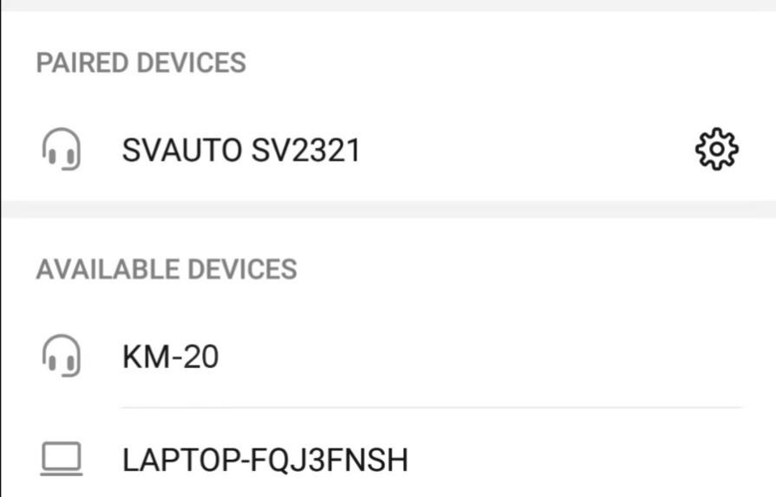

- SD Mode
Short press the to switch to SD mode. It will play the songs on micro SD card.
We prepare a 128MB micro SD card with 8 songs inside for you.
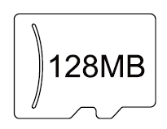

If the storage is not enough for you, you can another bigger storage micro SD card for the unit.
It can support Max. 32GB micro SD card with MP3 format songs.

RECORDING
Press the to record your singing songs. And press again to stop the recording and play your recording song.

Notice: When it plays the recording song, the playing mode will switch to SD mode automatically. If you want to record another song, please press to set back the BT mode.

SING ALONG
Short press the to turn on the vocal eliminator. Then you can sing along with background music.
Notice: It may not eliminate the full song depends on different music source.

MAGIC VOICE
Long press the to turn on the magic voice function. Long press the again to switch another magic voice.

There are 4 magic voice mode.

Others
1. Echo Effect control
Switch the to ON or OFF the echo effect.
2. LED light control
Long press theto turn ON or OFF the LED light.

APPENDIX
Songs
1 | ABC Song
2 | Baby Shark
3 | Be My Friend
4 | Bingo
5 | By the Beach
6 | Humpty Dumpty
7 | Old Macdonald Had Some Vowels
8 | Twinkle, Twinkle, Little Star

Singing Fun
ABC Song
A B C D E F G
H I J K L M N O P
Q R S T U V
W X Y AND Z
Now you turn my ABC
Tell me what you think of me

A B C D E F G
H I J K L M N O P
Q R S T U V
W X Y AND Z
Now you turn out ABC
Let us sing your ABC
All together sing with me
Let us try out ABC

A B C D E F G
H I J K L M N O P
Q R S T U V
W X Y AND Z
Now you heard out ABC
Let us sing your ABC

Baby Shark
Baby shark doo doo doo doo doo doo
Baby shark doo doo doo doo doo doo
Baby shark doo doo doo doo doo doo
Baby shark

Mummy shark doo doo doo doo doo doo
Mummy shark doo doo doo doo doo doo
Mummy shark doo doo doo doo doo doo
Mummy shark

Daddy shark doo doo doo doo doo doo
Daddy shark doo doo doo doo doo doo
Daddy shark doo doo doo doo doo doo
Daddy shark

Grandma shark doo doo doo doo doo doo
Grandma shark doo doo doo doo doo doo
Grandma shark doo doo doo doo doo doo
Grandma shark

Grandpa shark doo doo doo doo doo doo
Grandpa shark doo doo doo doo doo doo
Grandpa shark doo doo doo doo doo doo
Grandpa shark

Let's go hunt doo doo doo doo doo doo
Let's go hunt doo doo doo doo doo doo
Let's go hunt doo doo doo doo doo doo
Let's go hunt

Run away doo doo doo doo doo doo
Run away doo doo doo doo doo doo
Run away doo doo doo doo doo doo
Run away

Safe at last doo doo doo doo doo doo
Safe at last doo doo doo doo doo doo
Safe at last doo doo doo doo doo doo
Safe at last
It's the end doo doo doo doo doo doo
It's the end doo doo doo doo doo doo
It's the end doo doo doo doo doo doo
It's the end
Be My Friend
Hold my hand be my friend
We will love with be together
Hold my hand be my friend
We will be the best friend
One day you were know
I love with be here for you
Hold my hand be my friend
We will be the best friend
Hold my hand be my friend
We will love with be together
Hold my hand be my friend
We will be the best friend
One day you were know
I love with be here for you
Hold my hand be my friend
We will be the best friend

Bingo
There was a farmer had a dog
And bingo was his name OH
B-I-N-G-O B-I-N-G-O B-I-N-G-O
And bingo was his name Oh

There was a farmer had a dog
And bingo was his name OH
I-N-G-O I-N-G-O I-N-G-O
And bingo was his name Oh

There was a farmer had a dog
And bingo was his name OH
N-G-O N-G-O N-G-O
And bingo was his name Oh

There was a farmer had a dog
And bingo was his name OH
G-O G-O G-O
And bingo was his name Oh

There was a farmer had a dog
And bingo was his name OH
O O O
And bingo was his name Oh

There was a farmer had a dog
And bingo was his name OH

And bingo was his name Oh

By the Beach
In the sun by the beach we are swimming
Play along with my friends swim all day
Come along wade along do your swimming
Just have fun laugh along play all day

In the sun by the beach we are kicking
Play along with my friends swim all day
Come along wade along do your kicking
Just have fun laugh along play all day

In the sun by the beach we are swimming
Play along with my friends swim all day
Come along wade along do your swimming
Just have fun laugh along play all day

In the sun by the beach we are paddling
Play along with my friends swim all day
Come along wade along do your paddling
Just have fun laugh along play all day

Humpty Dumpty
Humpty Dumpty sat on a wall
Humpty Dumpty had a great fall
All the king's horses and all the King's men
Couldn't put Humpty Dumpty together again

Humpty Dumpty sat on a wall
Humpty Dumpty had a great fall
All the king's horses and all the King's men
Couldn't put Humpty Dumpty together again

Old Macdonald Had Some Vowels
Old MacDonald had some vowels
A-E-I-O-U

And the very first vowel
Is the letter A
Let's see what we can do

With an AA here and an ah ah there
Here an A there and ah
Everywhere an A ah

Old MacDonald had some vowels
A-E-I-O-U

Old MacDonald had some vowels
A-E-I-O-U

And the second little vowel
Is the letter E
Let's see what it can do
With an EE here and an eh eh there
Here an E there an eh
Everywhere an E eh

Old MacDonald had some vowels
A-E-I-O-U

Old MacDonald had some vowels
A-E-I-O-U

And the third little vowel
Is the letter I
Let's see what it can do
With an I I here and an ih ih there
Here an I there an ih
Everywhere an I ih

Old MacDonald had some vowels
A-E-I-O-U

Old McDonald had some vowels
A-E-I-O-U
And the fourth little vowel
Is the letter O
Let's see what it can do

With an OO here and an ah ah there
Here and O there an ah
Everywhere an O ah

Old MacDonald had some vowels
A-E-I-O-U

Old MacDonald had some vowels
A-E-I-O-U
And the last little vowel was the letter U
Let's see what it can do
With a UU here and a uh uh there
Here a U there a uh
Everywhere a U uh

Old MacDonald had some vowels
A-E-I-O-U

Twinkle, Twinkle, Little Star
Twinkle twinkle little star
How I wonder what you are
Up above the world so high
Like a diamond in the sky
Twinkle twinkle little star
How I wonder what you are

When the blazing sun is gone
When he nothing shines upon
Then you show your little light
Twinkle twinkle all the night
Twinkle twinkle little star
How I wonder what you are
Twinkle twinkle little star
How I wonder what you are

IMPORTANT NOTE:

Creating and developing the KOMVOX products is accompanied by a responsibility that we at KOMVOX take very seriously. We make every effort to ensure the accuracy of the information, which forms the value of our products. However, errors sometimes can occur. It is important for you to know that we stand behind our products and encourage you to contact us at service@comvox.com.cn

Supplier’s Declaration of Conformity
Brand: KOMVOX
Model: KM-20
Product Name: Angel Wing Karaoke Microphone
Company: KOMVOX Technology CO., Ltd.
Address: A409, Landkun Group Building, 29 Baoshi Road, Bao’an District, Shenzhen, Guangdong, China
Email: service @comvox.com.cn

THIS DEVICE COMPLIES WITH PART 15 OF THE FCC RULES. OPERATION IS SUBJECT TO THE FOLLOWING TWO CONDITIONS: (1) THIS DEVICE MAY NOT CAUSE HARMFUL INTERFERENCE, AND (2) THIS DEVICE MUST ACCPET ANY INTERFERENCE RECEIVED, INCLUDING INTERFERENCE THAT MAY CAUSE UNDESIRED OPERATION.
CAN ICES-3 (B)/NMB-3(B)

Caution: Changes or modifications not expressly approved by the party responsible for compliance could void the user’s authority to operate the equipment.

WARNING:
CHOKING HAZARD- Small parts
Not for children under 3 yrs.

